## Properties of the Road Tool - Legend and Manifest

By default, roads are not included in **Legend** and **Manifest**. To change this you to activate the road object on a **Legend & Manifest** section.

There you can also choose the manifest value as **Default** or **Dimensions** and set custom **Entry name** (see the image below)

**To activate road on your plan’s legend and/or manifest:**

* Select object.
* On the **Legend & Manifest** section of the properties palette clock on **False** on **Show in legend** section to make it **True**.
* 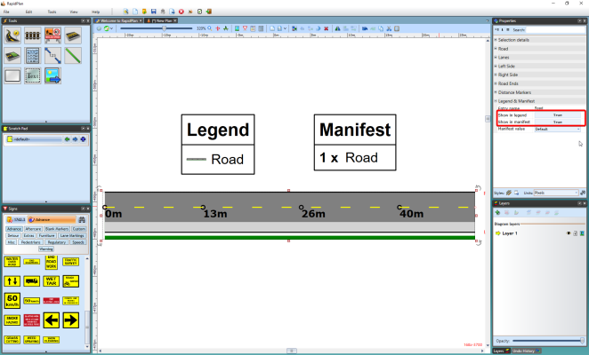
* Legend_and_Manifest_Properties
* 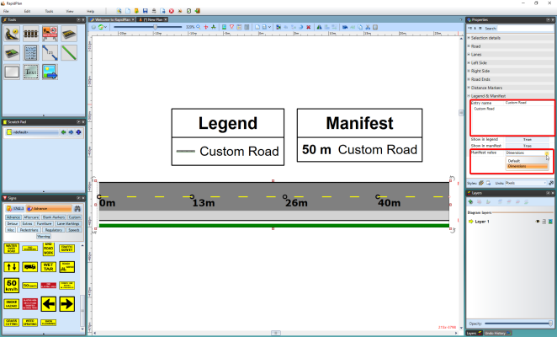
* Custom_Entry_name_and_Manifest_value
* **Note that this function is in the properties of all objects in RapidPlan**